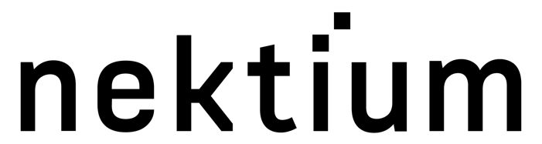

22 June 2023

PRESS RELEASE

Nektium secures new CITES trade permits
for Rhodiola rosea raw material

Spain’s authorities have certified the entirety of Nektium’s Rhodiolife® Rhodiola rosea inventory as CITES-compliant.
The approval means the Las Palmas-based company now has permits in place to commercialise large volumes of Rhodiolife® for customers within the EU and worldwide, both directly and via its network of global distributors.
In February, CITES incorporated Rhodiola spp. into Appendix II, its list of endangered species that are subject to international trade controls. On 20 May, the EU added Rhodiola spp. to Annex B, its equivalent list of species subject to restrictions. Subsequent to this, Nektium applied for trade permits for its existing Rhodiolife® stocks. These were granted on 16 June.
Bruno Berheide, Nektium’s Commercial & Partnerships Director, said: “Our approved Rhodiolife® stocks are sufficiently abundant to meet market demand for the foreseeable future. This is a major boost for the Rhodiola rosea category, which continues to thrive. At the same time, we are continuing to communicate regularly with our suppliers to guarantee compliant raw material from future harvests to ensure long-term continuity of supply.”
CITES is the Convention on International Trade in Endangered Species of Flora and Fauna. Although a voluntary organisation, its decisions are considered binding for the 184 countries that are members.
Rhodiola rosea is one of nature’s most potent adaptogens, offering a range of scientifically proven cognitive health and sports performance benefits. The popularity of the plant, which grows wild in the remote Altai mountains in south and central Asia, has put pressure on supplies, leading to over-harvesting. Historically, Nektium has relied on wild Rhodiola rosea roots harvested using sustainable practices. But the company recently pioneered the large-scale cultivation of Rhodiola rosea at levels sufficient to satisfy market demand.
ENDS

For more information please contact:
Richard Clarke, Ingredient Communications
richard@ingredientcommuncations.com

About Nektium
Based on the island of Gran Canaria, Spain, Nektium specialises in the supply of branded and generic botanical ingredients of the highest quality. The business was born out of two friends’ shared passion for the phytochemistry and pharmacology of botanicals and their applications in health and wellness. When it was first established in 1997, little was known about many of these botanical extracts, but the team at Nektium made it their mission to explore and unleash their potential health benefits. Today, the company is still defined by this solid foundation of dedicated relationships and its love for nature and research. Nektium’s flagship products are Zynamite®, a proprietary mango leaf extract (Mangifera indica), Rhodiolife®, a rhodiola plant extract (Rhodiola rosea) as well as Xanthigen®, a proprietary botanical blend for weight management.

